**G-Edge Resource Map**

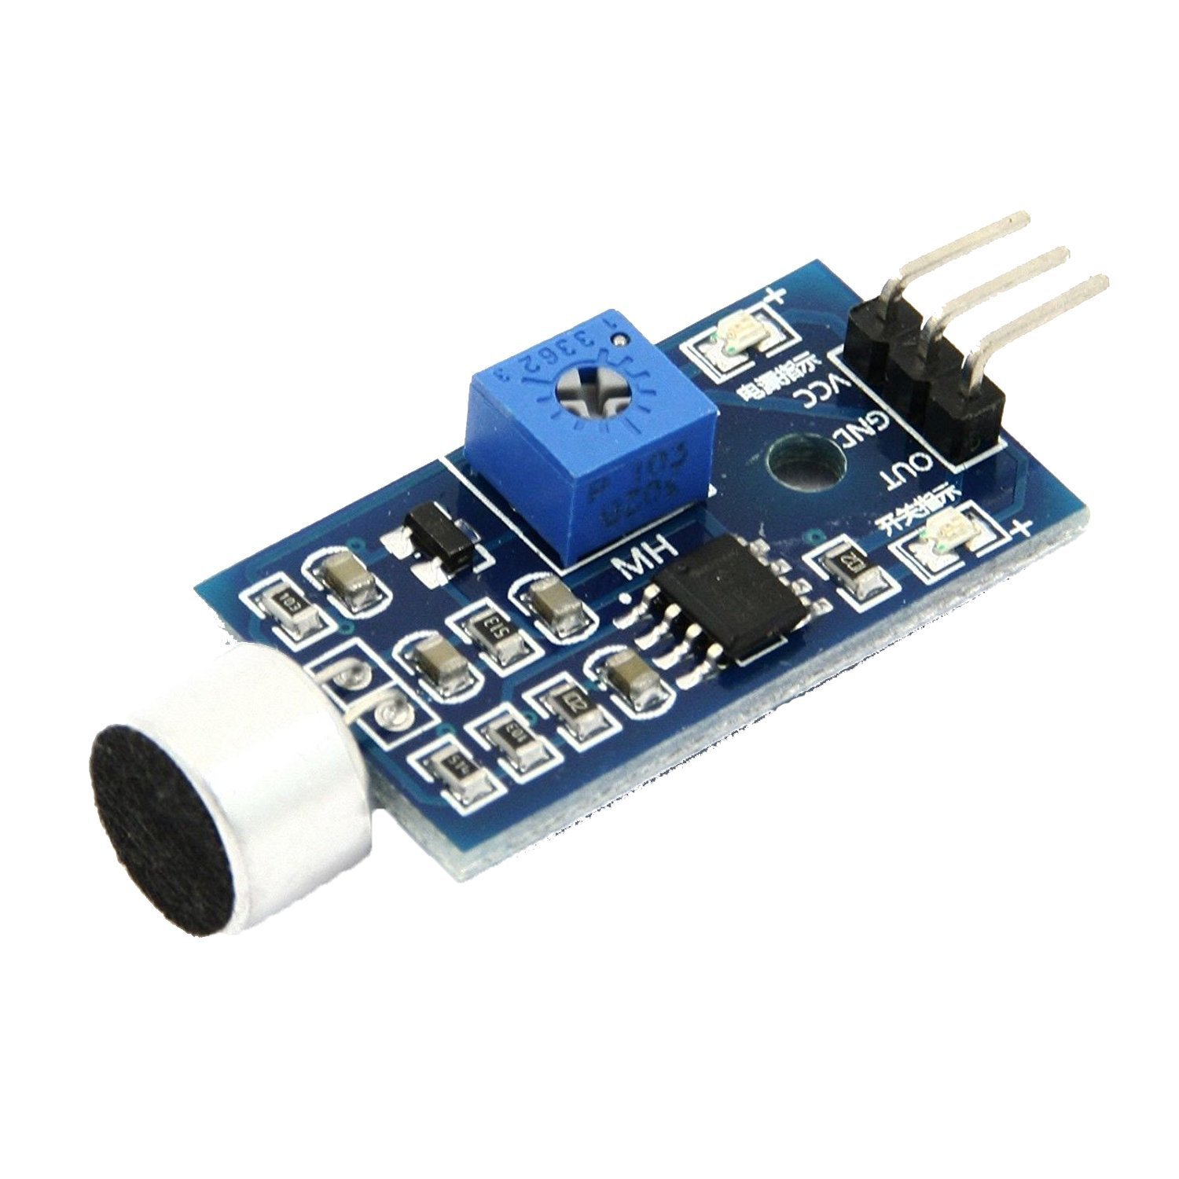

**Analog Sound Sensor**

|  |  |
| --- | --- |
| **Sensor pins** | **ESP32 pins** |
| VCC | 3.3V |
| GND | GND |
| OUT | GPIO34 |

**TCS3200 Color Sensor**

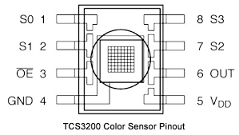

|  |  |
| --- | --- |
| **Sensor pins** | **ESP32 pins** |
| VCC | 3.3V (Thru’ jumper) |
| GND | GND |
| S0 | 3.3V (HIGH) |
| S1 | GND (LOW) |
| S2 | GPIO16 |
| S3 | GPIO17 |
| OUT | GPIO18 |

**DHT11 Temperature & Humidity Sensor**

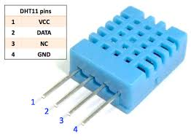

|  |  |
| --- | --- |
| **Sensor pins** | **ESP32 pins** |
| VCC | 3.3V |
| DATA | GPIO23 |
| NC | --- |
| GND | GND |

**Relay**

|  |  |
| --- | --- |
| **Relay pins** | **ESP32 pins** |
| VCC (Coil supply) | 5V |
| GND switching pin  thru’ transistor | GPIO19 |

Relay NO (Normally Open) contact to be brought out to screw terminals

**MPU6050 3-axis accelerometer & gyroscope Sensor**

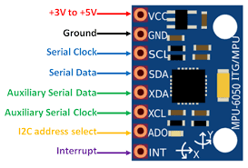

|  |  |
| --- | --- |
| **Sensor pins** | **ESP32 pins** |
| VCC | 3.3V |
| GND | GND |
| SCL | GPIO22 |
| SDA | GPIO21 |

**Analog Pin header**

|  |
| --- |
| 3.3V |
| GPIO35 |
| GPIO36 |
| GPIO39 |
| GND |

**Header for I2S interface ( INMP441 microphone)**

|  |  |
| --- | --- |
| **INMP441 signal** | **ESP32** |
| SCK | GPIO14 |
| SD | GPIO32 |
| WS | GPIO15 |
| L/R | GND |
| GND | GND |
| VDD | 3.3V |
|  |  |